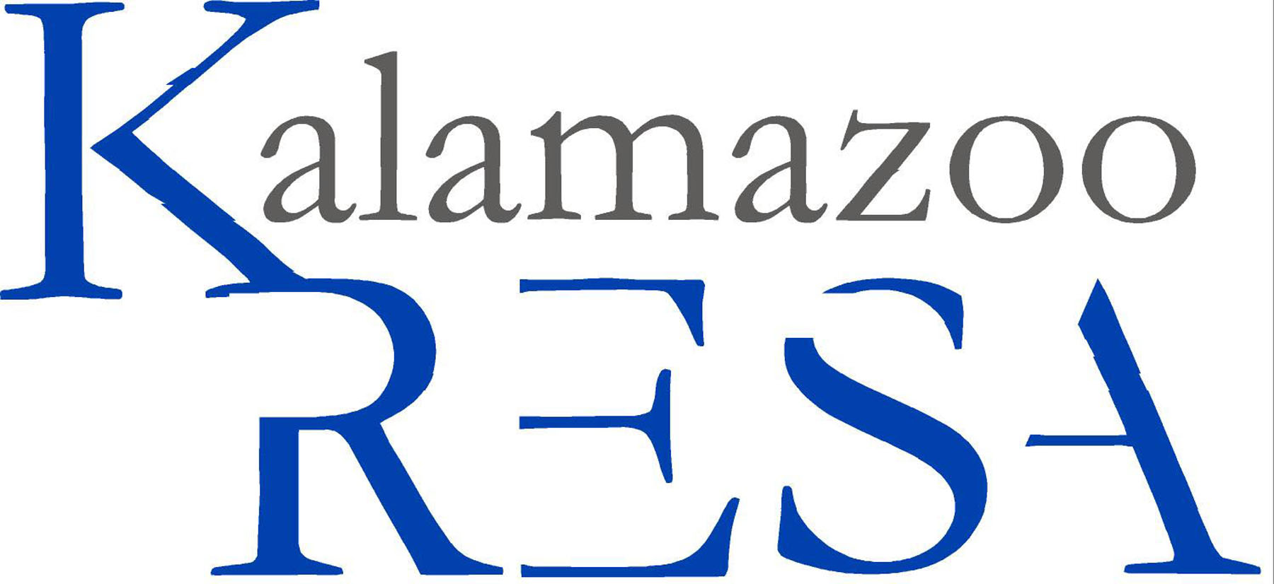
Kalamazoo Regional Educational Service Agency
Job Description

Job Title: Instructional Technologist
Reports To: Instructional Technologist/Data Specialist
FLSA Status: Non-exempt
Prepared By: Technology KB
Approved By: Human Resources
Prepared Date: 01/2014
Last Revised Date: 01/2014

Summary:
This position is responsible for working within KRESA programs and our constituent districts to create and implement sustainable and impactful systems of embedded technology to support teaching and learning.

Essential Duties and Responsibilities:
- Collaborate with administrators and teachers to develop a plan for integrating technology into standards based curriculum designs
- Model the integration of technology into classroom instruction
- Promote the use of online curricular resources for teachers and students
- Coordinate professional development for staff which focuses on the integration of technology to improve teaching and learning
- Monitor the use of instructional technology to ensure that resources and activities are preparing students for 21st century skills
- Assist in the creation and management of new technology learning initiatives. This includes supporting the change from traditional modes of instruction to innovative modes which utilize technology and address differentiated learning styles
- Remain current in the instructional technology profession through participation in relevant professional associations (RITS and KRESA Instructional Technologist team meetings), conferences, research, and publishing
- Promote and support various Technology Readiness initiatives as directed
- Participation in the Classroom Readiness Activity training and facilitation during the spring and summer 2014 sessions
- Regular and consistent attendance
- Other duties as assigned

Must have knowledge of and comply with the policies and procedures contained in the Kalamazoo RESA handbook

Education and/or Experience:
- Minimum of BS/BA degree in Education. Minimum of five years’ classroom teaching experience, including demonstrated success of technology integration.

Page 2 Instructional Technologist

- Experience in facilitation of high-quality professional development with a focus on technology training.
- Experience in integrating technology into teaching and learning.
- Knowledge of Michigan standards and curriculum design.
- Knowledge of data driven decision making.
- Experience in effective instruction and best practices in the classroom.
- Experience in coaching teachers with respect to instructional and technological skills.
- Demonstrate the ability to learn new technologies and instructional practices on a continuous basis.
- Experience in creating online learning opportunities within a learning management systems such as Moodle.
- Experience in the implementation of METS and national technology standards.
- Successful written and verbal communication skills with both students and adults.
- Ability to work independently and with a team in problem solving situations.

Certificates, License, Registration:
- Possess a valid Michigan teaching certificate.

Other Skill & Abilities:
- Effectively present information in front of groups and engage in audience
- Ability to communicate effectively including listening
- Keep administrator abreast of activity
- Works in a team oriented fashion
- Ability to efficiently use computer and applicable software
- Ability to problem solve
- Maintains confidentiality
- Displays willingness to support and make decisions with sound judgment in timely manner
- Develops strategies to achieve goals
- Performs duties as workload necessitates
- Adapts to frequent changes in the work environment
- Uses equipment and materials properly
- Practices safe work habits

Supervisory Responsibilities:
This job has no supervisory responsibilities.

Physical Demands:
Reasonable accommodations may be made to enable individuals with disabilities to perform the essential functions. The employee is frequently required to reach with arms and hands, stand, walk and sit. The employee must frequently lift and/or move up to ten pounds and occasionally lift and/or move up to 25 pounds. Specific vision abilities required by this job include close vision, depth perception and ability to adjust focus.

Page 3 Job Title: Instructional Technologist

Work Environment:
The noise level in the work environment is usually quiet.

The employee shall remain free of any alcohol or nonprescribed controlled substance in the workplace throughout his/her employment in the District.

It is the policy of Kalamazoo Regional Educational Service Agency that no discriminating practices based on gender/sex, sexual orientation, race, religion, height, weight, color, age, national origin, disability or any other status covered by federal, state or local law be allowed during any program, activity, service or in employment. The following positions at Kalamazoo RESA have been designated to handle inquiries regarding the nondiscrimination policy. Human Resources Director, Tom Zahrt; Assistant Superintendents: Margaret McGlinchey & Laurie Montgomery. Contact information: 269-250-9200, 1819 E. Milham Avenue, Portage, MI 49002.

